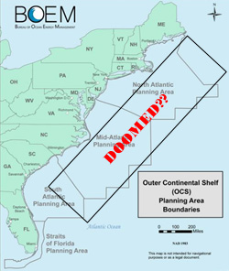
Fact Sheet

At the direction of President Trump’s Executive Orders the Bureau of Ocean Energy Management (BOEM) is seeking information and comments from the public on a NEW five-year National Outer Continental Shelf Oil and Gas Leasing Program (National OCS Program) for 2019-2024 pursuant to the Outer Continental Shelf (OCS) Lands Act.

(If this sounds familiar, President Obama just completed a 5-year plan earlier this year. A new plan was not required until 2022. So this new plan is being fast tracked.)

The new plan includes the entire Atlantic Ocean from Maine to Florida, including the waters off New Jersey.

What is at Stake
Remarkable Habitat and Ecology at Risk
New Jersey and New York coasts boast thousands of miles of combined marine habitats including coastline, back-bay, estuary, and rivers will be exposed to pollution and connected to the Atlantic Ocean.

The physical, hydrodynamic, and biological characteristics of the ocean off the Jersey Shore are unique in the world, as more than 300 species of fish, nearly 350 species of birds, 5 species of sea turtles, and many marine mammals such as 20 species of whales and dolphins, 1 species of porpoise, and 4 species of seals, frequent this region. Nine endangered species, four of which are whales, can be found in these ocean waters, including the Atlantic Right Whale, one of world’s most endangered. The region also serves as an essential migratory pathway for many of these species.

Economics: Clean Ocean Economy Threatened.
The clean ocean economy supported by these marine resources supports billions of dollars.

New Jersey:
The Jersey Shore sustains the state’s economy of the region with its bounty of natural resources and intrinsic values for millions of people through tourism. Tourism brings more than $32 billion to NJ’s economy each year and provides jobs to more than 500,000 people.

Recreational and commercial fisheries in NJ provide enormous economic benefits, including revenue, food production, and recreational activities. In 2014, recreational fishing supported nearly 20,000 jobs and resulted in $2 billion of retail sales. Commercial fishing supports nearly 7,300 jobs and provides $152 million in landings, not including restaurant and retail sales.

New York
In 2012, just Long Island’s tourism in Nassau and Suffolk Counties provides $1.7 billion dollars to the states GDP, and supported 42,000 jobs. Recreational fishing generated $369 million in sales, and commercial fishing landings were valued at $37 million dollars.

Not Worth the Specs of Oil-
Current estimates of the amount of technically recoverable oil off the entire Atlantic coast from Maine to Florida would only last the nation approximately 229 days, and the amount of technically recoverable gas would only last approximately 562 days. Even if estimates double, the amount value is a fraction of the Clean Ocean Economy.

The Oil and Gas Drilling Industry is Dirty, harmful, and can be lethal.
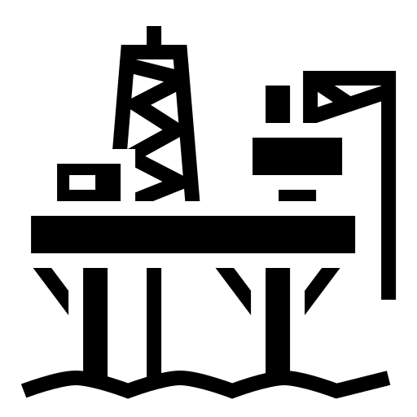
Offshore oil and gas development, causes substantial environmental impacts, including: (a) onshore damage due to infrastructure, (b) water pollution from drilling muds and the water brought-up from a well with oil and gas (called “produced waters”), (c) noise from seismic surveys, (d) air pollution, and (e) oil spills.

The BP Horizon disaster in the Gulf of Mexico is clear evidence of the dangers associated with offshore drilling, including costing the lives of 11 people, devastating coastal economies and countless livelihoods, and killing untold marine animals, as well as continuing to cause harm to marine life as documented by a steady flow of studies.

Drilling Any Where in the Atlantic Ocean Threatens the region:
Oil spills travel vast distances, and the Gulf Stream and Labrador Ocean Current all flow toward New Jersey making the region vulnerable to impacts from spills anywhere in the Atlantic Ocean.

Opposition widespread
Bi-partisan opposition against drilling off the New Jersey coast has included every Governor since 1985, and a majority of the congressional delegation and most coastal towns. Over last 30 years, thousands of citizens have voiced opposition, many coastal towns, and state and local officials also oppose offshore oil and gas development.

Sea Level Rise, Ocean Acidification, and Ocean Warming is real
—Reducing Fossil Fuels is essential and saves money
Energy conservation and efficiency measures can significantly reduce the nation’s need to explore and drill for nonrenewable resources, such as oil and natural gas.

Comments are due by August 17, 2017.
Frame-work for comments:

Dear Ms. Kelly Hammerle
National Program Manager
Bureau of Ocean Energy Management

I__________ citizen of ___________ I strongly oppose further consideration of drilling off my coast. Oil and gas exploration, development, drilling and production polluting and harmful to a clean ocean economy.

The coast is important to me, my family and/or my business because: _____________________________________________________________________________________________.

The resources I/we enjoy the ocean include (clean water, fish, marine life) :

This region is not appropriate for oil and gas development.

I trust you will consider and reply to my concerns.

Sincerely,
Your Name.

HOW DO I SEND IT IN?
Submit comments by clicking here and following the directions

By Mail:
Your comments must be post-marked by August 17, 2017. If you do mail in comments, please send a copy to Clean Ocean Action so we can keep a record of your comments for the record.

Kelly Hammerle
National Program Manager
Bureau of Ocean Energy Management
U.S. Department of Interior
45600 Woodland Road
Mailstop VAM-LD
Sterling, VA 20166

