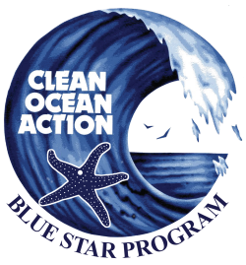
Municipal Blue Star Program

Congratulations – you are almost Blue Star certified! Please fill out the following form and email it to education@cleanoceanaction.org. Municipalities have the opportunity to submit the Final Application twice per year: May 1st and November 1st.
Name: Click here to enter text.
Municipality: Click here to enter text.
County: Click here to enter text.
Which department, committee, or organization do you represent (if applicable)? Click here to enter text.
Phone Number (office): Click here to enter text. Phone Number (cell): Click here to enter text.

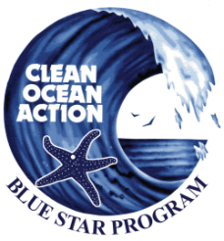
Sustainable Jersey Categories | Sustainable Jersey Sub-Categories | Sustainable Jersey Actions that count as Blue Star Actions | Number of Points | Completed
Climate Mitigation & Adaptation |  | Climate Action Plan | 10 Points | ☐
 |  | Climate Adaptation: Flooding Risk | 20 Points | ☐
Community Partnership & Outreach |  | Community Education & Outreach | 10 Points | ☐
 |  | Education for Sustainability Programs | 10 Points | ☐
 |  | Green Challenges & Community Programs | 10 Points | ☐
 | Green Fairs | Green Your Green Fair | 10 Points | ☐
 |  | Hold a Green Fair | 10 Points | ☐
Green Design | Green Design Municipal Buildings | Upgrade/Retrofit Water Conservation | 10 Points | ☐
Innovation & Demonstration Projects |  | Green Roofs | 10 Points | ☐
 |  | Innovative Community Project 1 | 10 Points | ☐
 |  | Rain Gardens | 10 Points | ☐
Land Use & Transportation |  | Green Building and Environmental Sustainability Element | 10 Points | ☐
Local Economies |  | Green Business Recognition Program | 10 Points | ☐
Natural Resources |  | Environmental Commission | 10 Points | ☐
 |  | Natural Resource Inventory | 20 Points | ☐
 |  | Open Space Plans | 10 Points | ☐
 |  | Water Conservation Education Program | 10 Points | ☐
 |  | Water Conservation Ordinance | 20 Points | ☐
 | Natural Resource Protection Ordinance | Environmental Assessment Ordinance | 10 Points | ☐
 |  | Habitat Conservation Ordinance | 10 Points | ☐
 | Tree & Woodlands Management | Community Forestry Plan and Tree Cover Goal | 20 Points | ☐
 |  | i-Tree Assessment of Municipal Trees | 10 Points | ☐
Operations & Maintenance | Green Purchasing Program | Adopt a Green Purchasing Policy by Ordinance | 10 Points | ☐
 |  | Adopt a Green Purchasing Policy by Resolution | 6 Points | ☐
 |  | Energy Efficient Appliances or Equipment | 10 Points | ☐
 |  | Green Cleaning Products | 10 Points | ☐
 |  | Green Maintenance Equipment and Materials | 10 Points | ☐
 | Grounds and Maintenance | Create a Policy | 10 Points | ☐
 |  | Efficient Landscape Design | 10 Points | ☐
 |  | Integrated Pest Management | 10 Points | ☐
 |  | Minimize Water Consumption | 10 Points | ☐
 |  | Recycled Materials and Composting | 10 Points | ☐

Sustainable Jersey Categories | Sustainable Jersey Sub-Categories | Sustainable Jersey Actions that count as Blue Star Actions | Number of Points | Completed
Waste Management |  | Prescription Drug Safety and Disposal | 10 Points | ☐
 | Recycling | Bulky Rigid Plastics | 10 Points | ☐
 |  | Recycling Education & Enforcement | 6 Points | ☐
 |  | Shrink Wrap | 10 Points | ☐
 | Waste Reduction | Backyard Composting Program | 6 Points | ☐
 |  | Grass - Cut It or Leave It Program | 6 Points | ☐
 |  | Materials Reuse Program | 10 Points | ☐
 |  | Reusable Bag Education Program | 6 Points | ☐
COA Additional Actions (choose 1 of 5) |  | Climate Adaptation: Flooding Risk* |  | ☐
 |  | Innovative Water Quality Project* |  | ☐
 |  | Model Stormwater Control Ordinance for Municipalities* |  | ☐
 |  | Plastic Bag Fee or Ban* |  | ☐
 |  | Stormwater Utility Support Resolution |  | ☐
 |  | Total Points | 420 Points
*may receive Sustainable Jersey points; please contact Sustainable Jersey prior to starting the project to confirm

Clean Ocean Action Additional Action
Which action did you complete?
Climate Adaptation Flooding Risk ☐
Innovative Water Quality Project ☐
Model Stormwater Control Ordinance for Municipalities ☐
Plastic Bag Fee or Ban ☐
Stormwater Utility Support Resolution ☐
When did you complete this action? Click here to enter text.
Please provide a synopsis of the project (if you received Sustainable Jersey points for any of the actions, please provide the content you submitted to Sustainable Jersey): Click here to enter text.
Please provide specific outcomes from the project: Click here to enter text.
Any additional information you wish to provide: Click here to enter text.

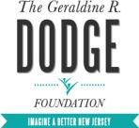
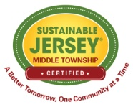
The Municipal Blue Star Program was made possible by funding from the Geraldine R. Dodge Foundation and collaborative support from Sustainable Jersey.

